**DAILY ONLINE ACTIVITIES SUMMARY**

|  |  |  |  |  |  |  |  |  |
| --- | --- | --- | --- | --- | --- | --- | --- | --- |
| **Date:** | **21-06-2020** | | | | | **Name:** | **Raksha S** | |
| **Sem & Sec** | **6th B** | | | | | **USN:** | **4AL17CS073** | |
| **Online Test Summary** | | | | | | | | |
| **Subject** | | **-** | | | | | | |
| **Max. Marks** | | **-** | | **Score** | | | **-** | |
| **Certification Course Summary** | | | | | | | | |
| **Course** | **FullStack Webdevelopment** | | | | | | | |
| **Certificate Provider** | | | **Udemy** | | **Duration** | | | **9 hrs** |
| **Coding Challenges** | | | | | | | | |
| **Problem Statement:**  1. Write a C Program to calculate Electricity Bill.  2. Write a Java Program to determine whether a given matrix is a sparse matrix. | | | | | | | | |
| **Status:** YES, Completed all Programs | | | | | | | | |
| **Uploaded the report in Github** | | | | | **YES** | | | |
| **If yes Repository name** | | | | | <https://github.com/raksha05/Daily-Status>/Raksha-4AL17CS073/Raksha | | | |
| **Uploaded the report in slack** | | | | | **YES** | | | |

Certification Course Details:

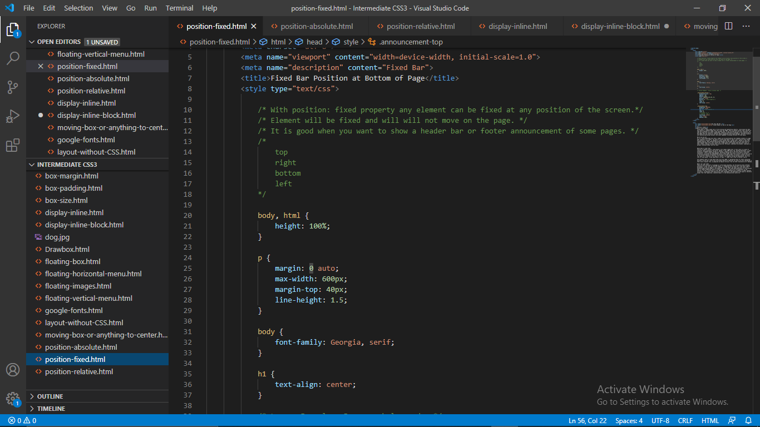

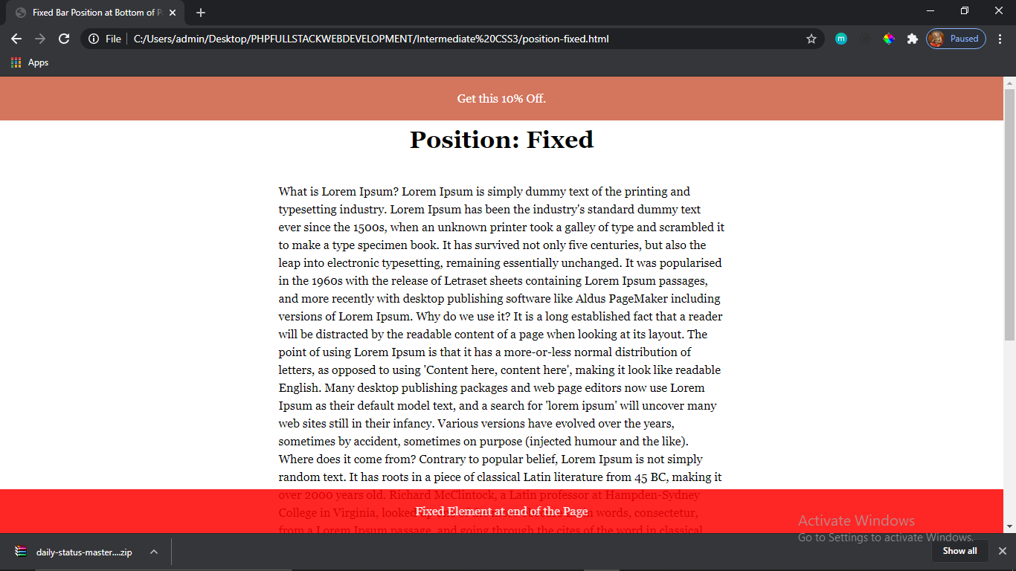

Today in certification course based on FullStack Webdevelopment I learnt margins width,height,top,opacity.etc.,,

Coding Challenges Details:

Program1:

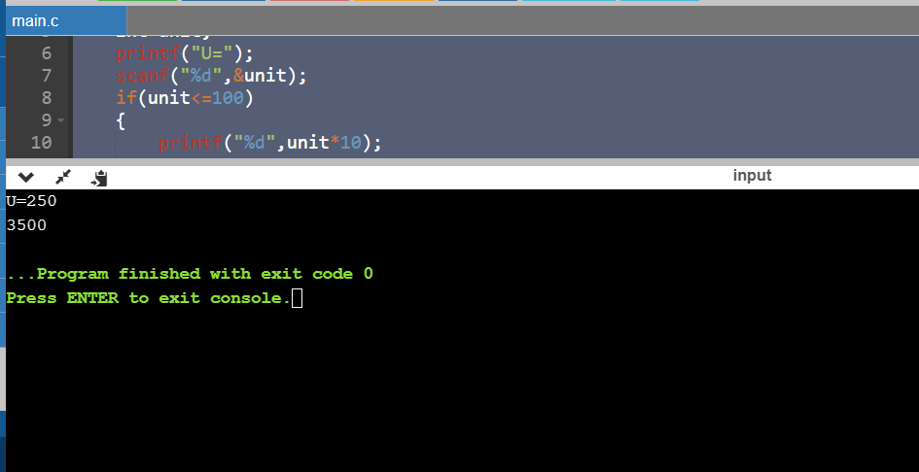

Program2:

